For renewal of the annual membership / Conference Seminars of the Planning Enforcement Officers Association Incorporated for the financial year 2020 - 2021.

In renewing your membership, you agree to comply with the PEOA Model Rules, Privacy Policy and Code of Conduct which can be found on our website at planning-enforcement.com.

Members name/s | $ / MEMBER
TOTAL

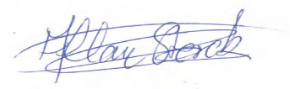
………………………………………
Allan Sterck - Treasurer
Email: treasurer@peoa.org.au

PAYMENT DETAILS
Payment can be made by Direct Deposit to:
Planning Enforcement Officers Association Inc
Police Credit Co-operative
BSB: 704-230
Acc No: 100163429 Carlton Branch

